**Aim:**

CREATE NODE-RED SERVICE

**Team ID:** PNT2022TMID51110

To create a web application create a Node-RED service.

**Step followed:**

* Navigated to the App creation page

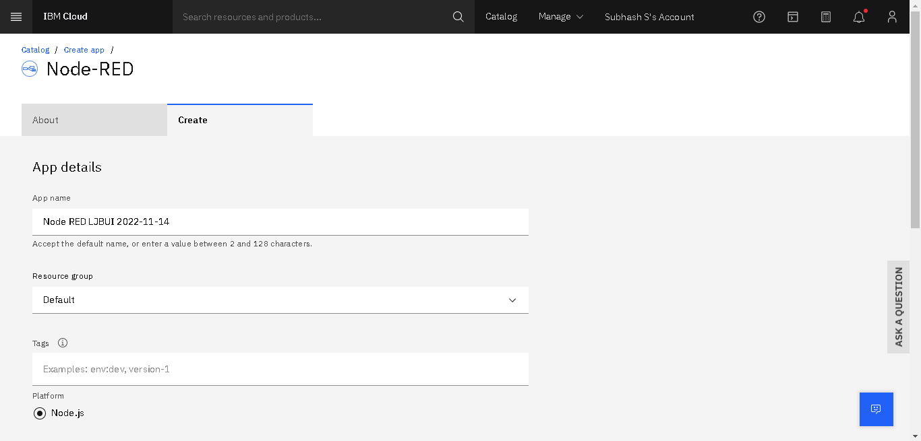

* Entered project details and clicon create and Deploy your app

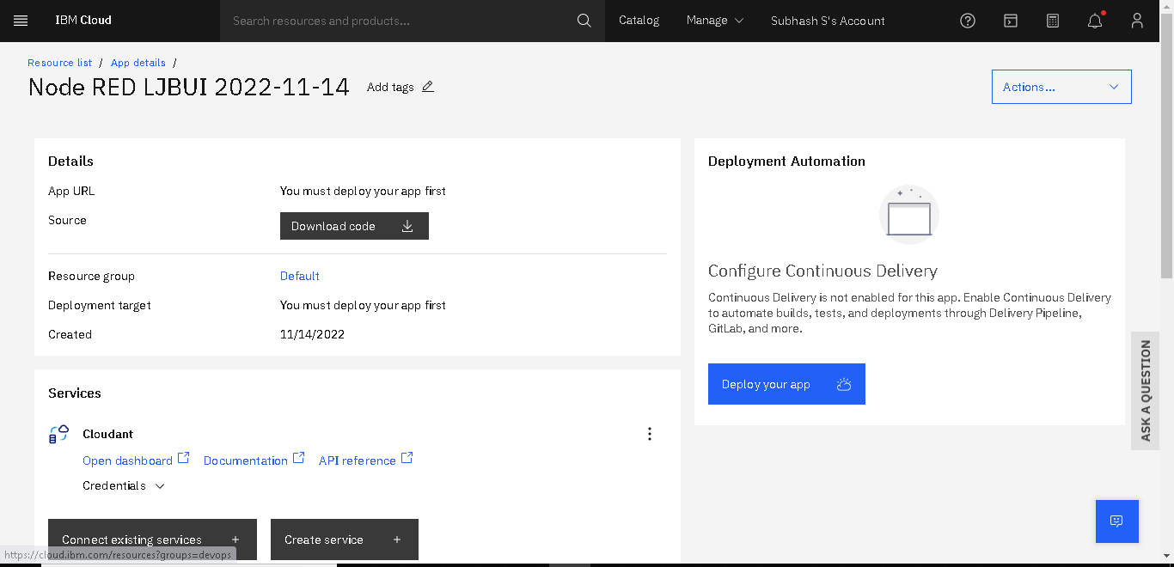ked

* **After this move towards the cloud Factory**

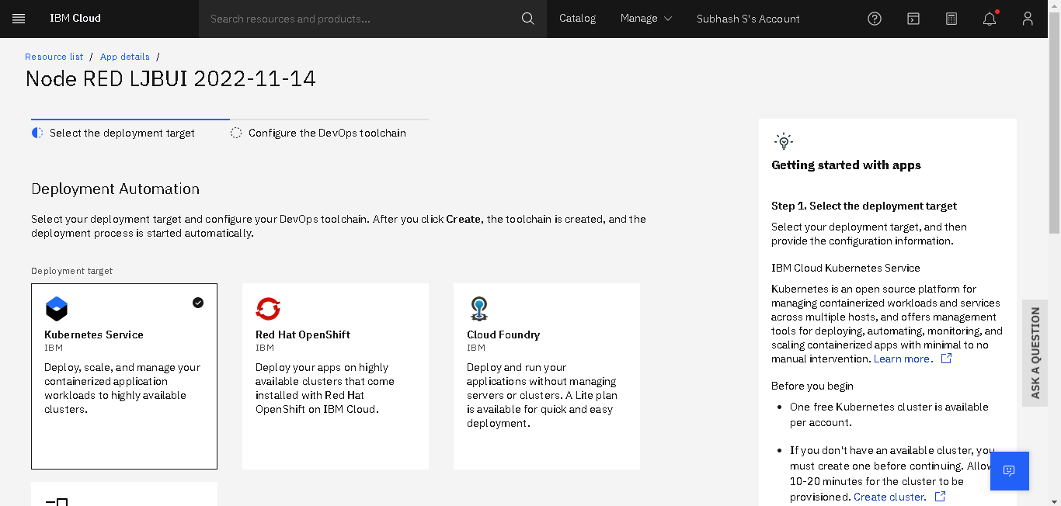

* 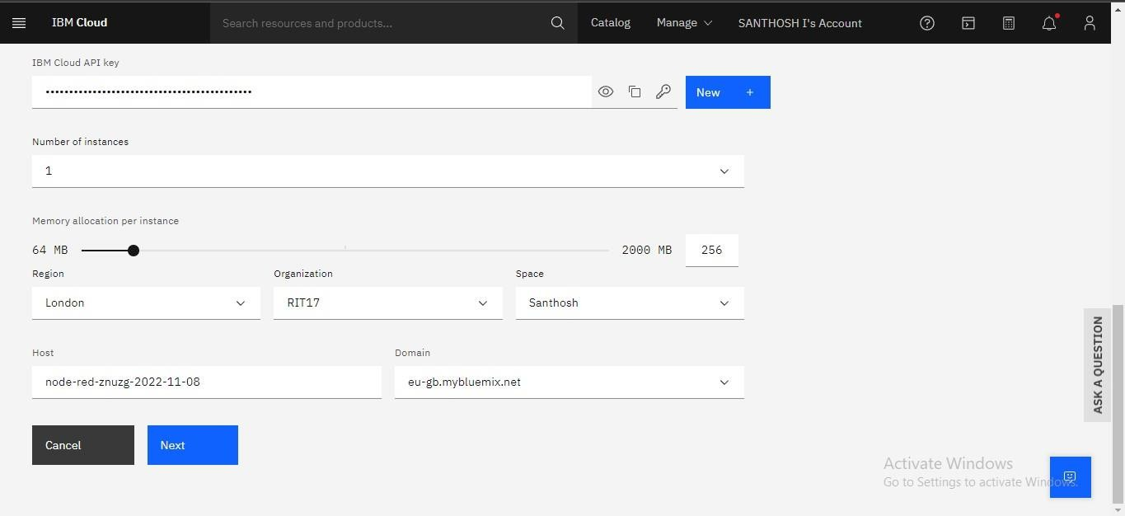Setting up the environment and deploying the app
* Pipeline Succeeded and Running

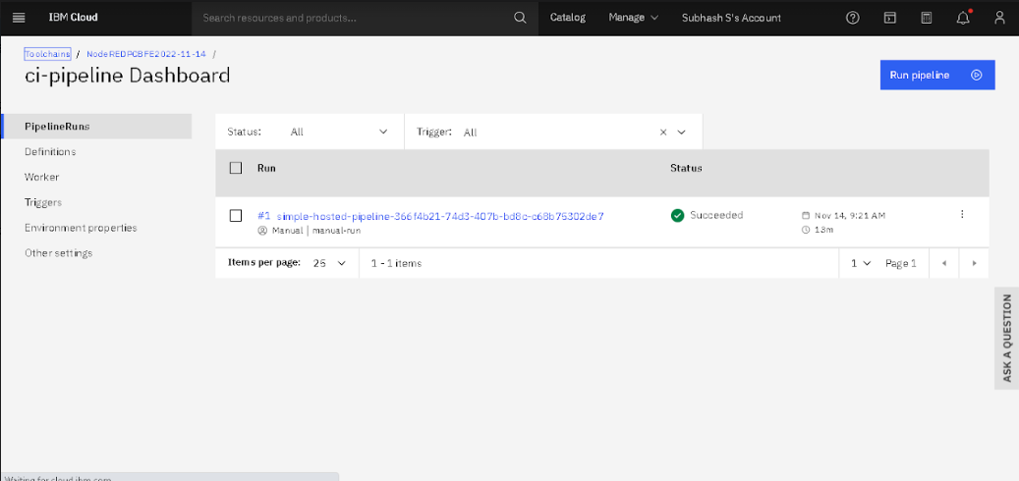

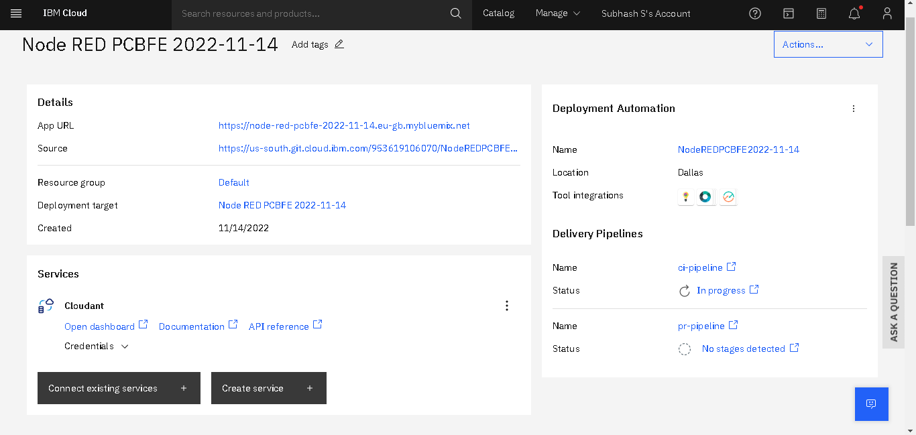

* Welcomed by the instance editor

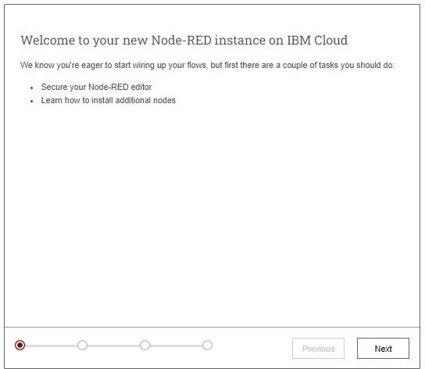

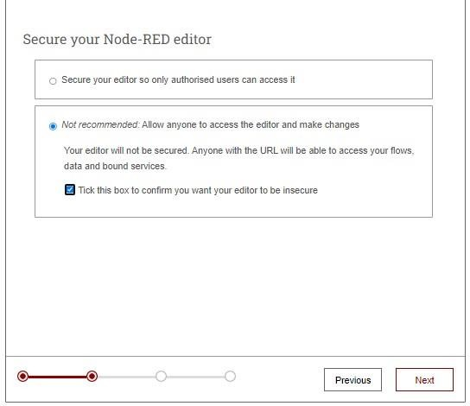

Next….

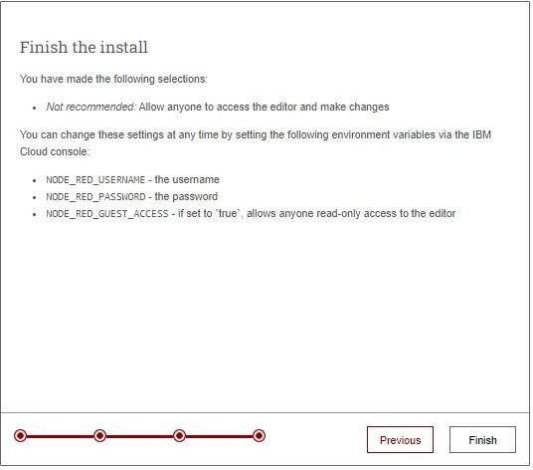

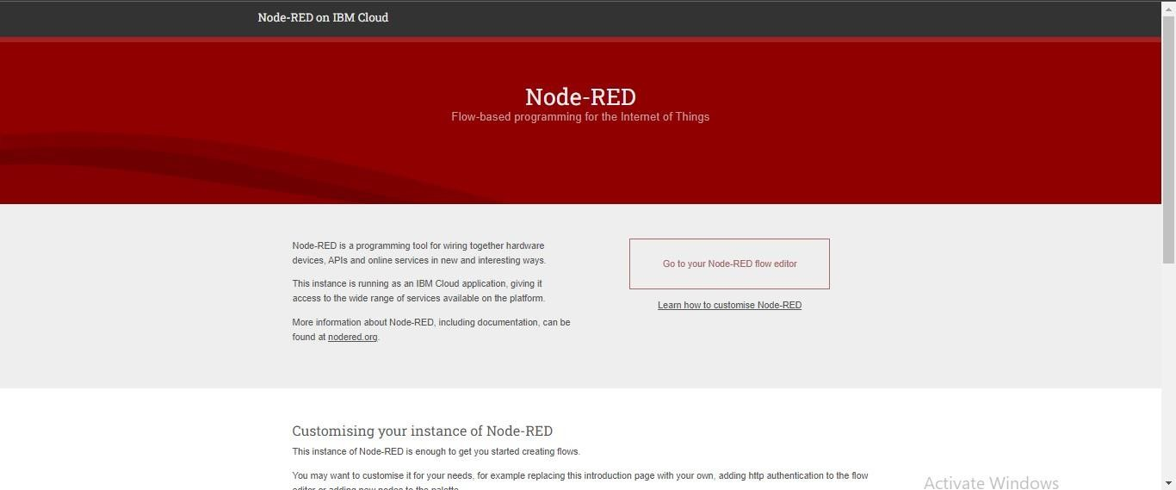

* 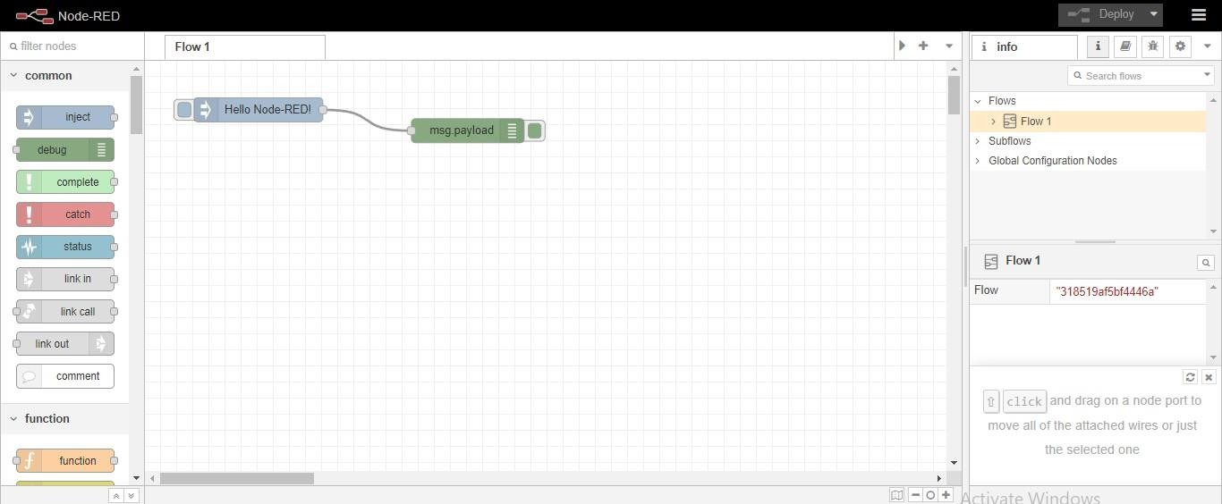Dragged and Drop the components in the editor

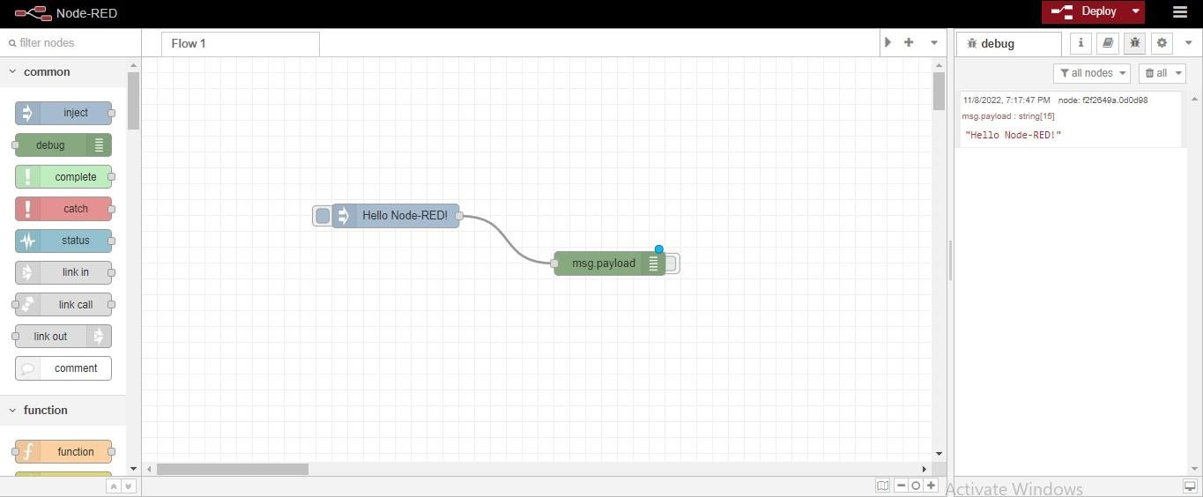

**Result**: Successfully created a Node RED service on IBM Cloud.